Report On
Talk conducted on
CAREERS IN MANAGEMENT

Date:- 20/07/2017
Place:- SIES COLLEGE OF ARTS,SCIENCE&COMMERCE,
Sion (E),
Mumbai.

The commerce department of SIES COLLEGE OF ARTS, SCIENCE & COMMERCE organized an interactive session for all the students of T.Y.Bcom on 20th July 2017 on a topic regarding CAREERS IN MANAGEMENT. It was held in the M.M.R. at 8:00 am.
The talk was conducted by the INDIAN BUSINESS SCHOOL (IBS) institute. It started with C.A. Mr. Avin Shah introducing the speaker for the day Prof.Hemant Purandare.
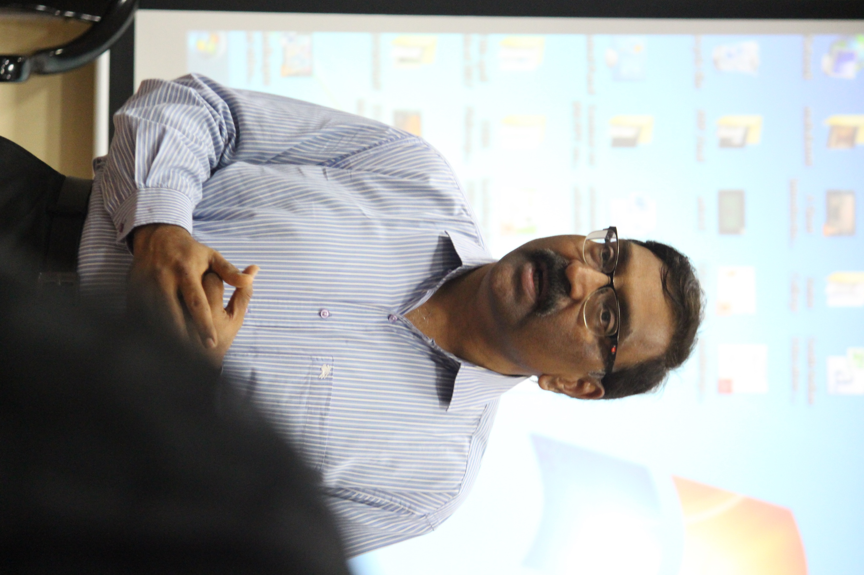

The main motive of this talk was to educate the graduating students about various careers in the field of management. The session was very interactive with the professor asking many students about their career plan and guiding them simultaneously. He gave a detailed explanation on the various segmentations of management studies and what are the ways to achieve success in the desired field. The participation of the students from both the divisions was strong .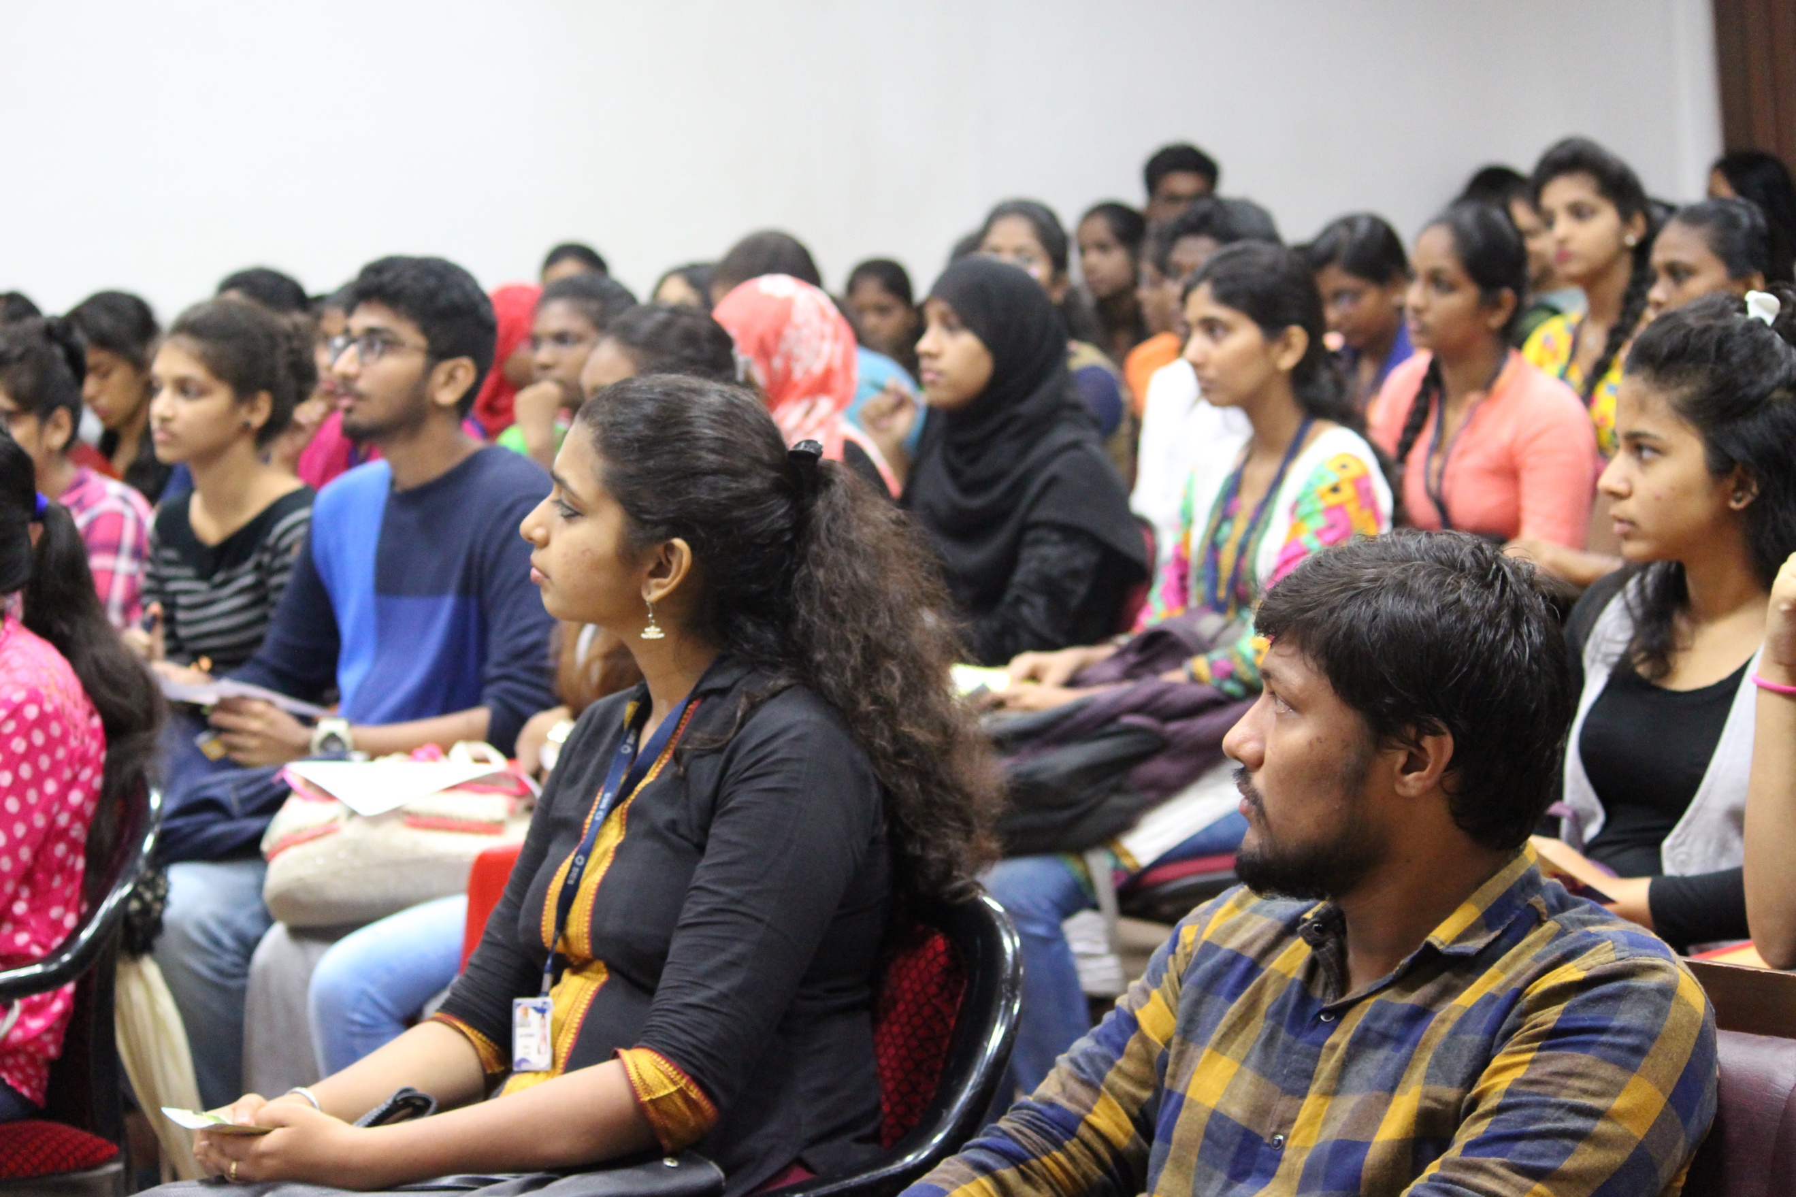

After the professor’s speech, a representative of the IBS institute took over the stage and explained about the various courses in management offered by the institute.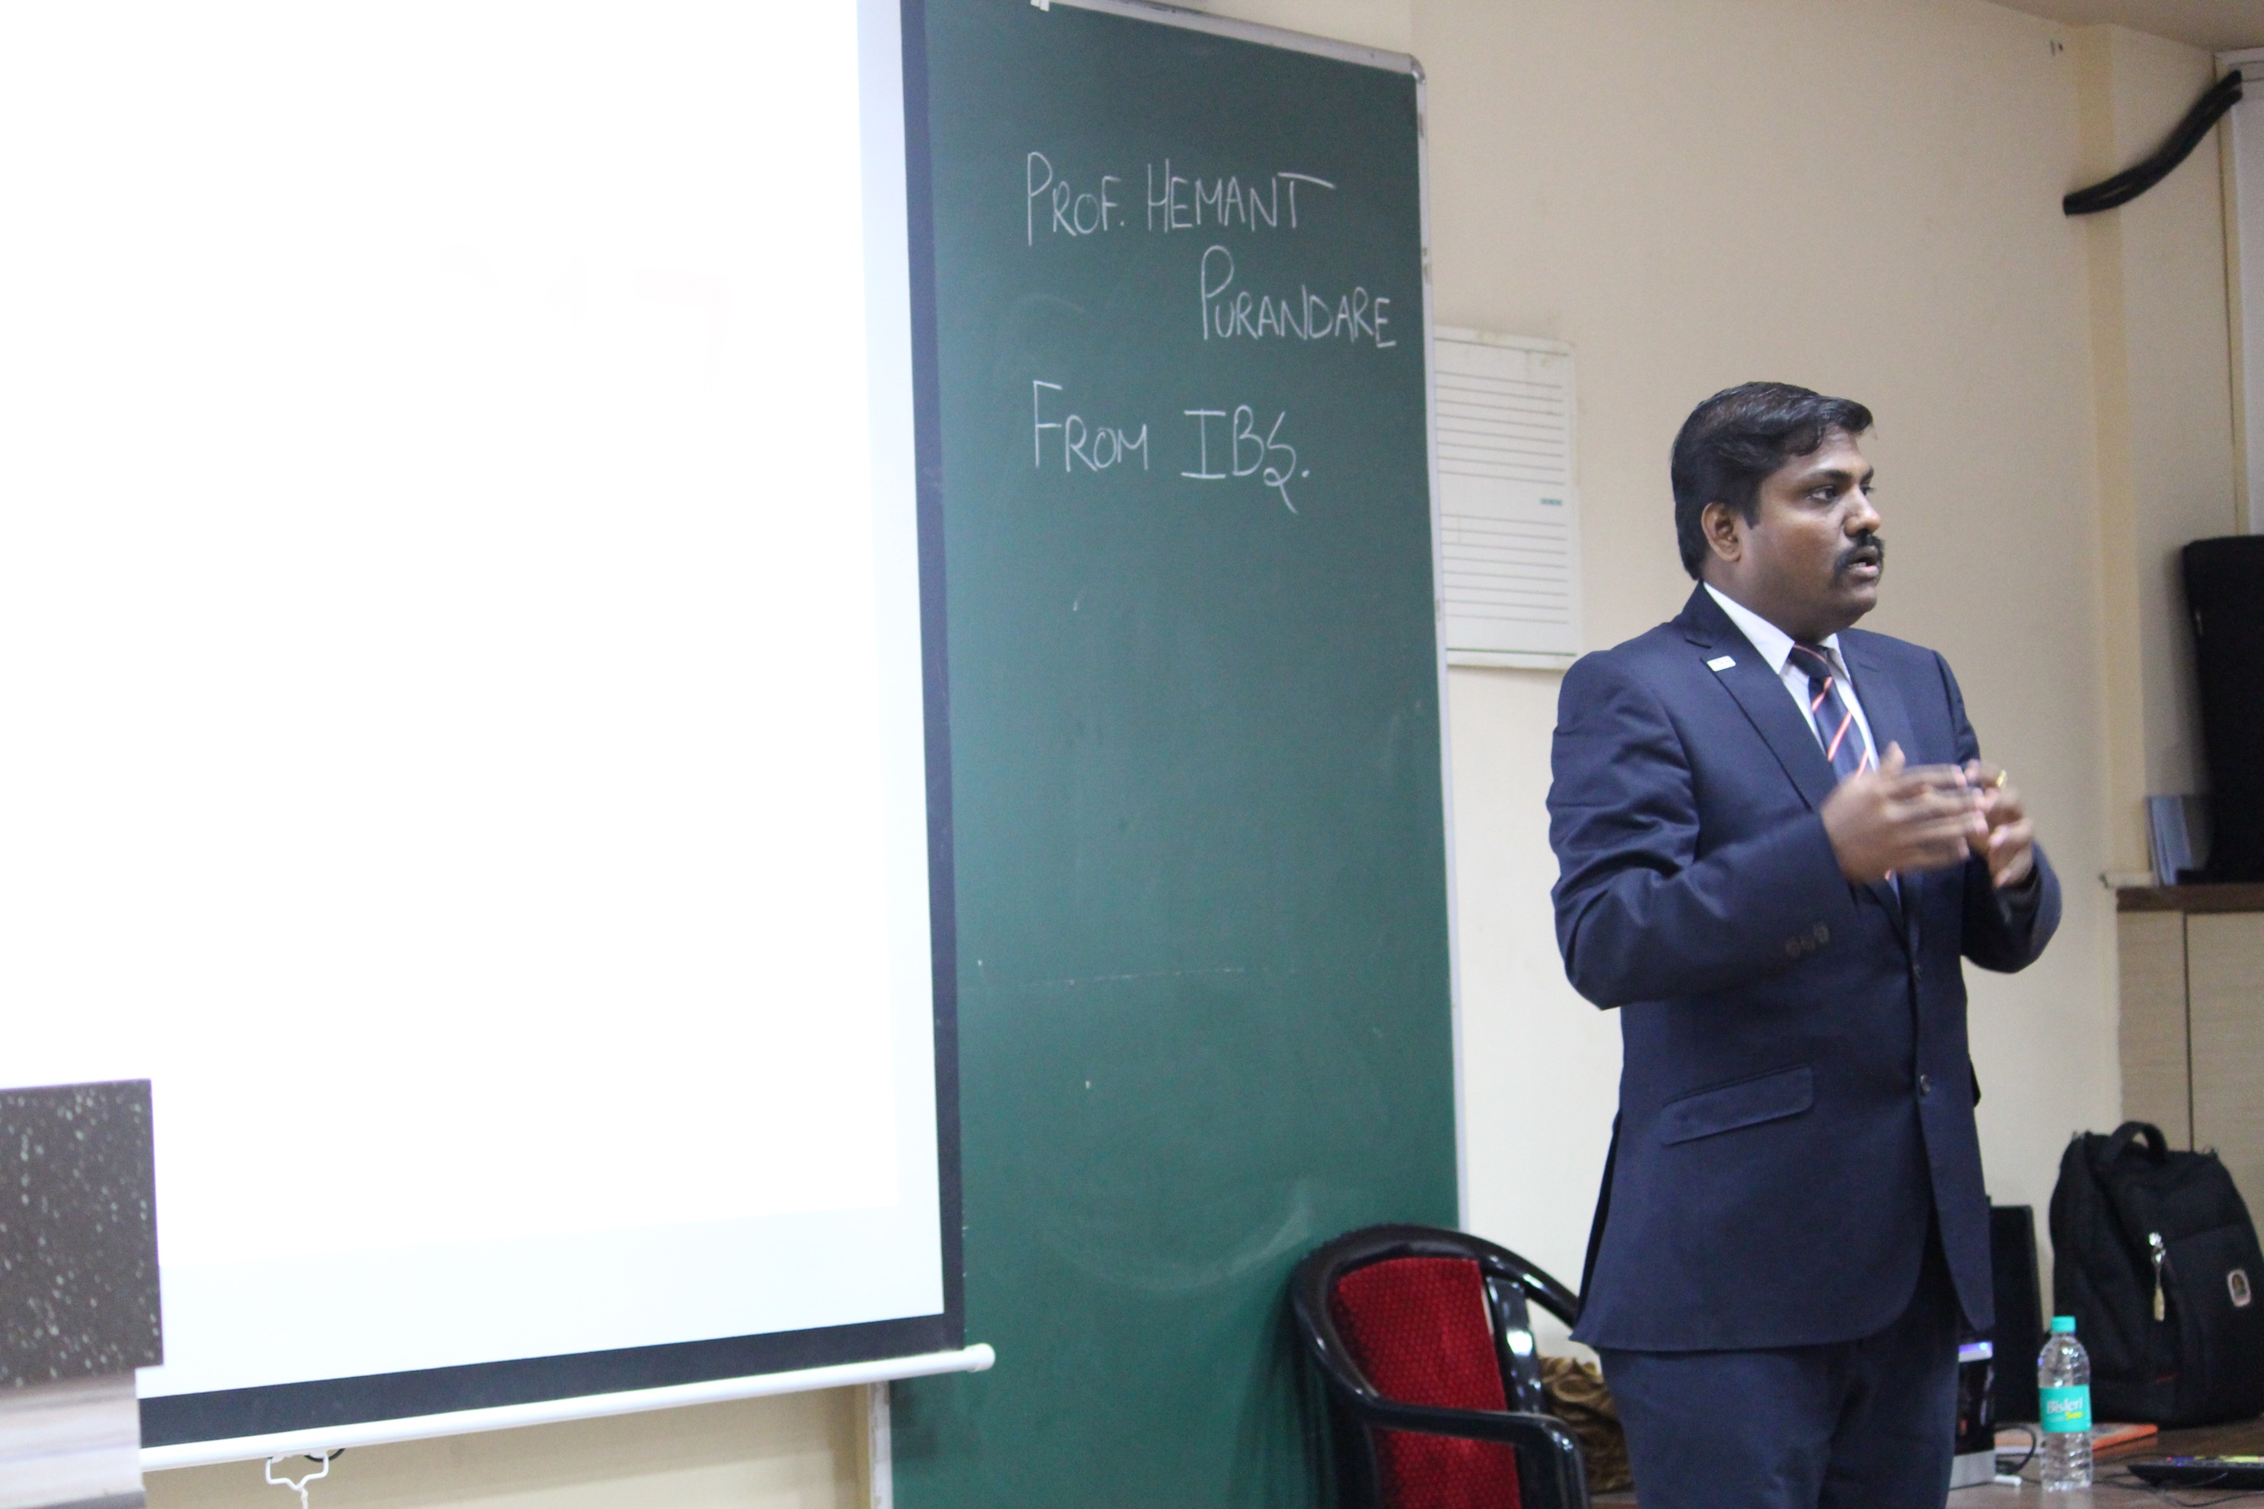 Overall the whole session was a success and was instrumental in educating the students about various career opportunities in management.

By,
Srinath Sridhar,
T.Y.Bcom (B) .

